Appendix: D Role based security system

Role based security system is maintained in this e-CourseMonitoring system. After log in, each user find his/her own dashboard based on his/her role. This outcome is describing below.

A table is shown below to describe the security system based on role based.

|  |  |  |  |  |  |  |  |
| --- | --- | --- | --- | --- | --- | --- | --- |
| S/N | Features | Roles | | | | | |
| Admin | CL | CM | PVC | DLT | Guest |
| 1 | Sign in to the system | ✔ | ✔ | ✔ | ✔ | ✔ | ✔ |
| 2 | See all faculty information | ✔ |  |  |  |  |  |
| 3 | Add faculty | ✔ |  |  |  |  |  |
| 4 | See all session information | ✔ |  |  |  |  |  |
| 5 | Add session | ✔ |  |  |  |  |  |
| 6 | See all teacher information | ✔ |  |  |  |  |  |
| 7 | Add teacher | ✔ |  |  |  |  |  |
| 8 | Unavailable/ available teacher | ✔ |  |  |  |  |  |
| 9 | See all course information | ✔ |  |  |  |  |  |
| 10 | Add course | ✔ |  |  |  |  |  |
| 11 | Make course unavailable/available | ✔ |  |  |  |  |  |
| 12 | See all session running course with faculty | ✔ |  |  |  |  |  |
| 13 | Assign course in specific session | ✔ |  |  |  |  |  |
| 14 | See curse authority information (cl, cm) for each session each course | ✔ |  |  |  |  |  |
| 15 | Assign course leader and course moderator | ✔ |  |  |  |  |  |
| 16 | See all faculty authority (PVC, DLT) | ✔ |  |  |  |  |  |
| 17 | Make faculty authority unavailable/available | ✔ |  |  |  |  |  |
| 18 | Assign faculty authority | ✔ |  |  |  |  |  |
| 19 | Database updating | ✔ |  |  |  |  |  |
| 20 | See own statistical reports |  | ✔ | ✔ | ✔ | ✔ |  |
| 21 | See own running course list with status |  | ✔ | ✔ |  |  |  |
| 22 | Generate CMR |  | ✔ |  |  |  |  |
| 23 | Update CMR before approved |  | ✔ |  |  |  |  |
| 24 | Approved CMR |  |  | ✔ |  |  |  |
| 25 | Update CMR before commented |  |  | ✔ |  |  |  |
| 26 | See the CMR data based on CL/ CM/ PVC/ DLT |  | ✔ | ✔ | ✔ | ✔ | ✔ |
| 27 | Comment to the CMR |  |  |  |  | ✔ |  |
| 28 | See all approved CMR for each session each faculty |  |  |  |  |  | ✔ |
| 29 | See all statistical reports for each session each faculty |  |  |  |  |  | ✔ |
| 30 | See all exceptional reports for each session each faculty |  |  |  |  |  | ✔ |
| 31 | Visit own profile | ✔ | ✔ | ✔ | ✔ | ✔ |  |
| 32 | Create new event | ✔ | ✔ | ✔ | ✔ | ✔ |  |
| 33 | See own event | ✔ | ✔ | ✔ | ✔ | ✔ |  |
| 34 | Change password | ✔ | ✔ | ✔ | ✔ | ✔ |  |
| 35 | Get notification for CMR status |  | ✔ | ✔ | ✔ | ✔ |  |
| 36 | Lock Screen feature | ✔ | ✔ | ✔ | ✔ | ✔ |  |

Role admin:

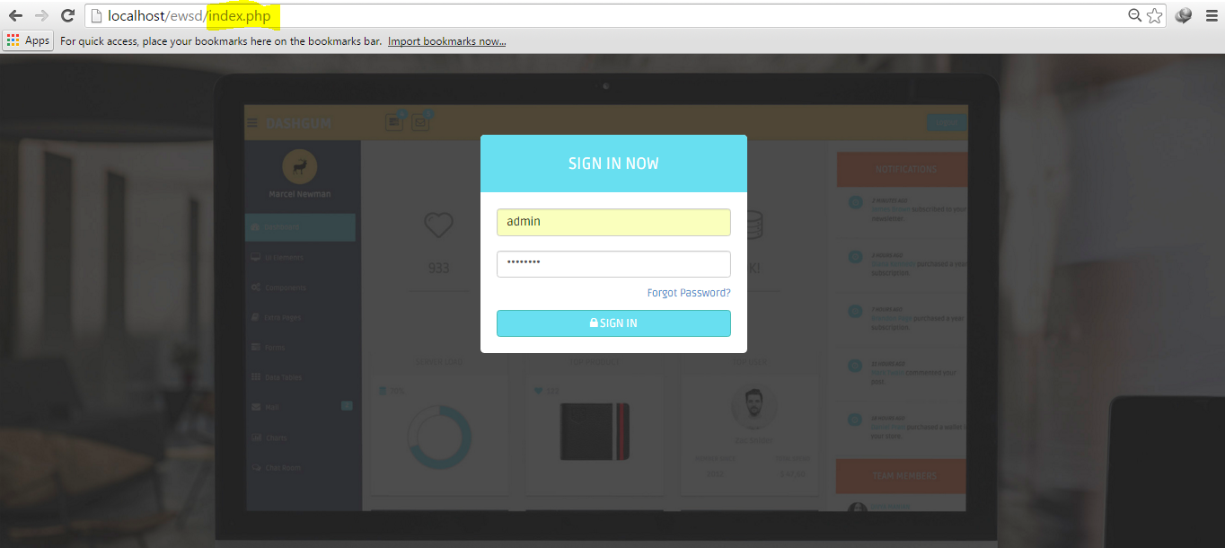  
 Figure 7.4.1 admin log in process

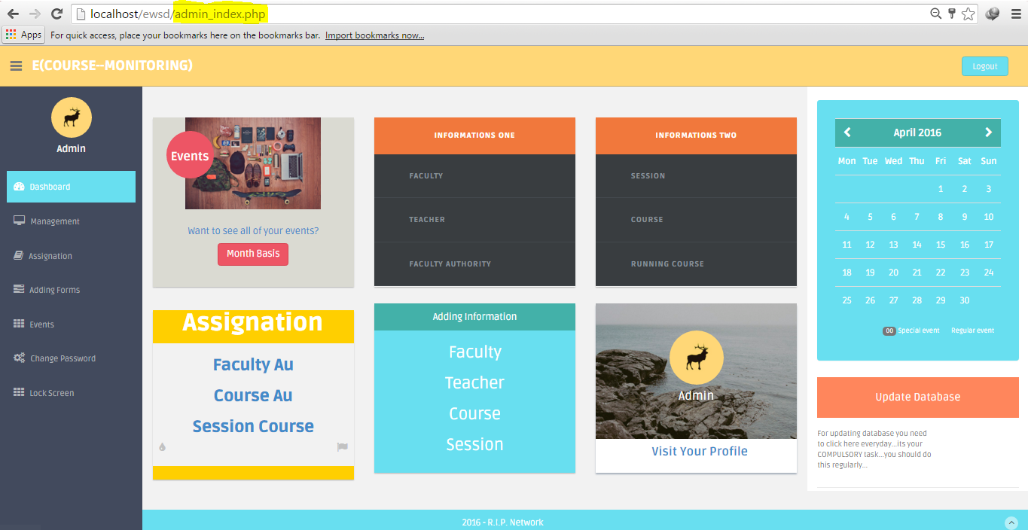  
 Figure: 7.4.2 admin dashboard

Role teacher:

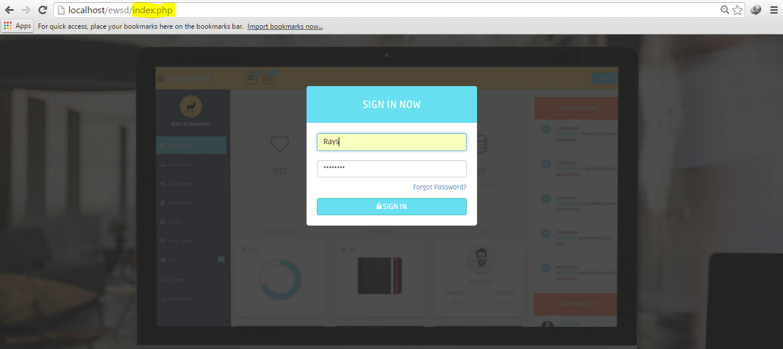

Figure: 7.4.3 teacher log in process

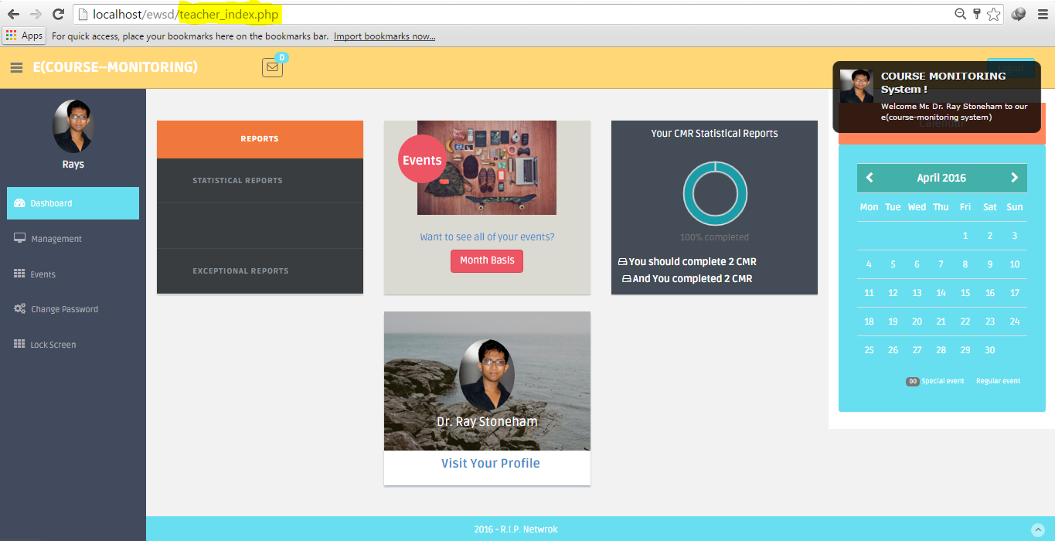

Figure: 7.4.4 teacher dashboard

Role guest:

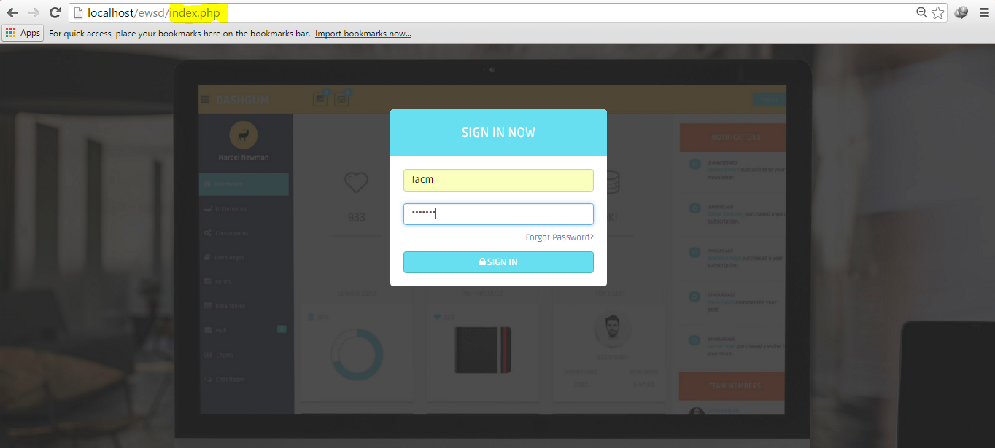

Figure: 7.4.5 guest log in process

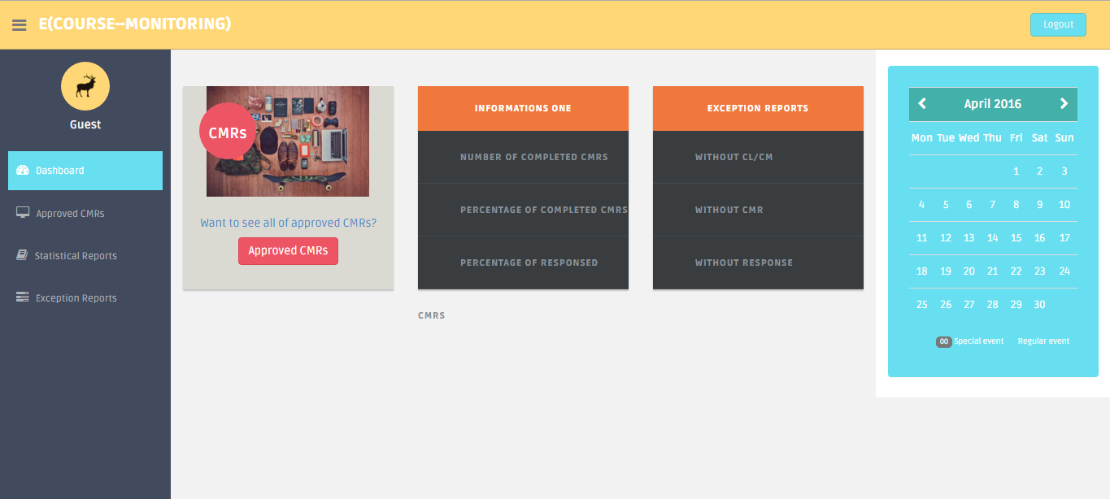

Figure: 7.4.6 Guest dashboard

Appendix: E Validation implementation

## Validation implementation

* Validation view in login page:

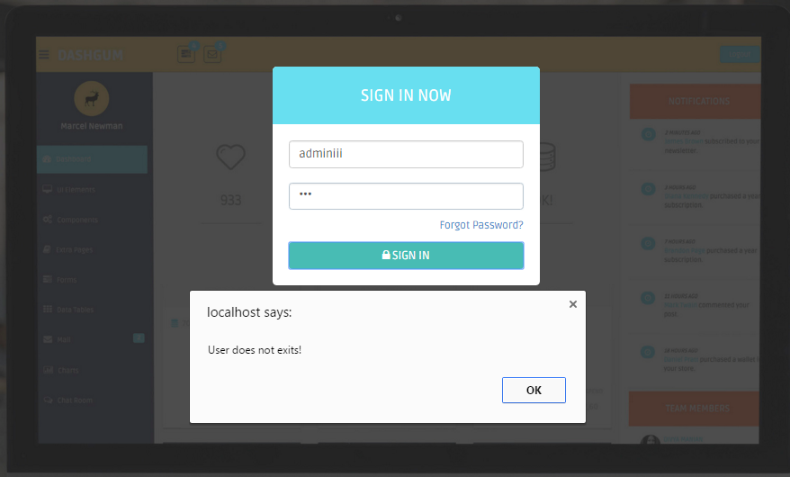  
 Figure: 1 validation check for log in (user name)

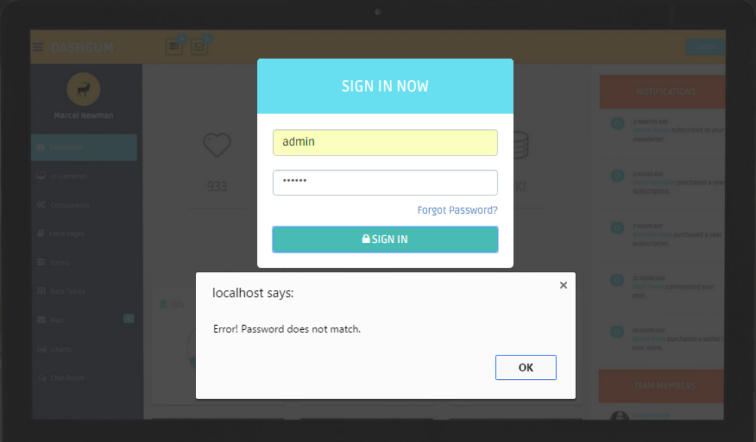 Figure: 2 validation check for log in (password)

* Validation view in faculty adding page:

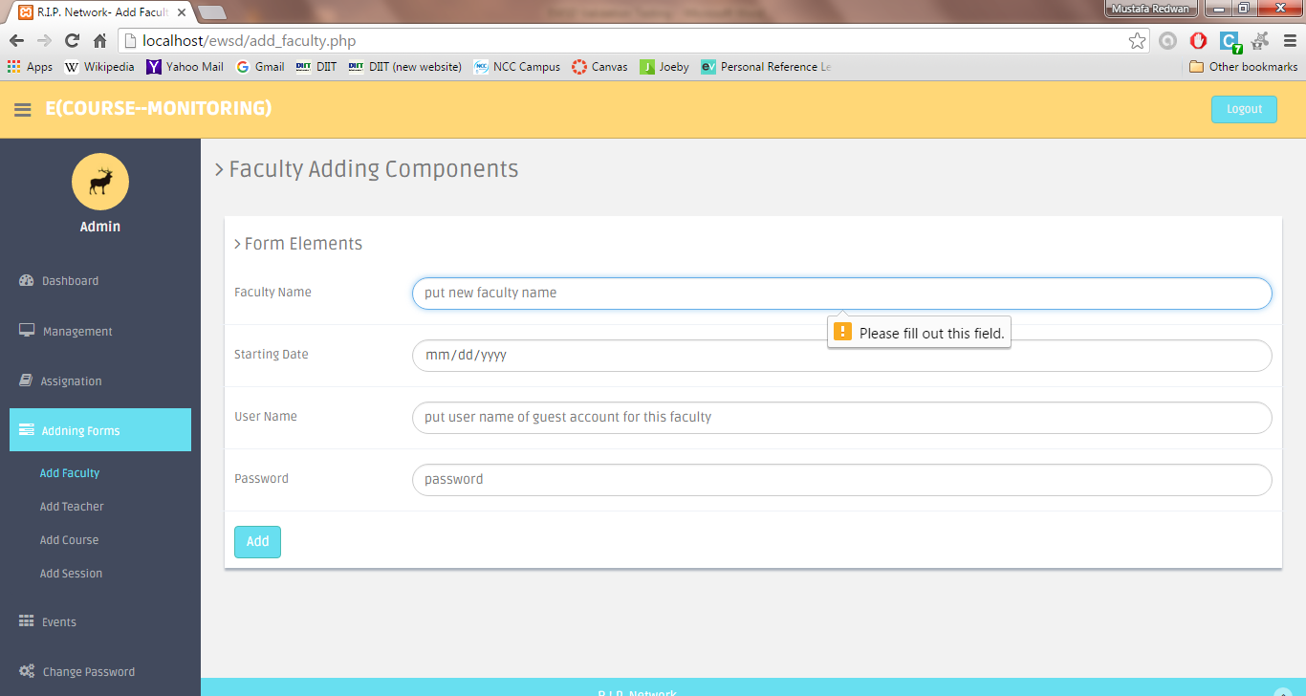

Figure: 3 Faculty Name must be filled out

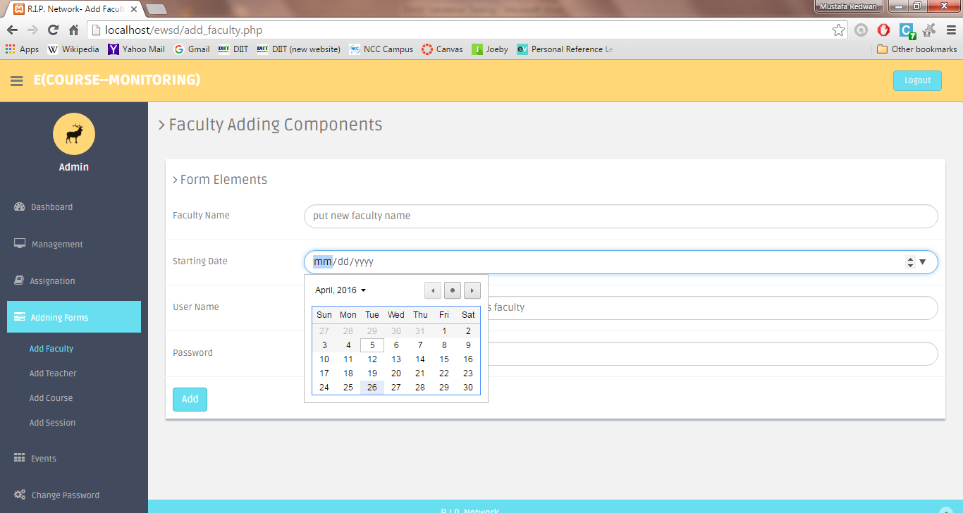

Figure: 4 Today’s or later date must be chosen. No previous date is allowed

* Validation view in teacher adding page:

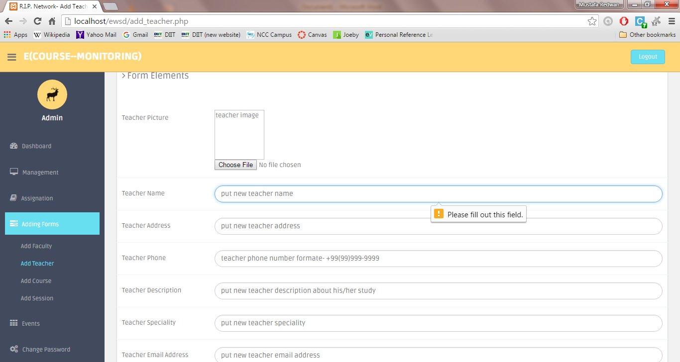  
 Figure: 5 teacher name must be filled up

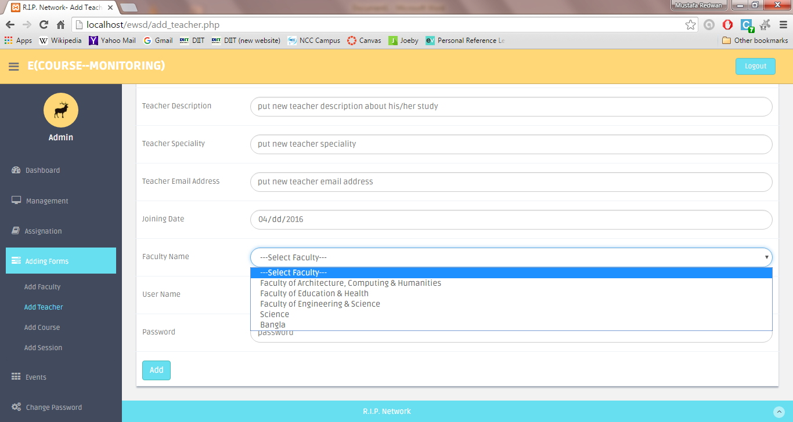

Figure: 6 Faculty Name must be selected

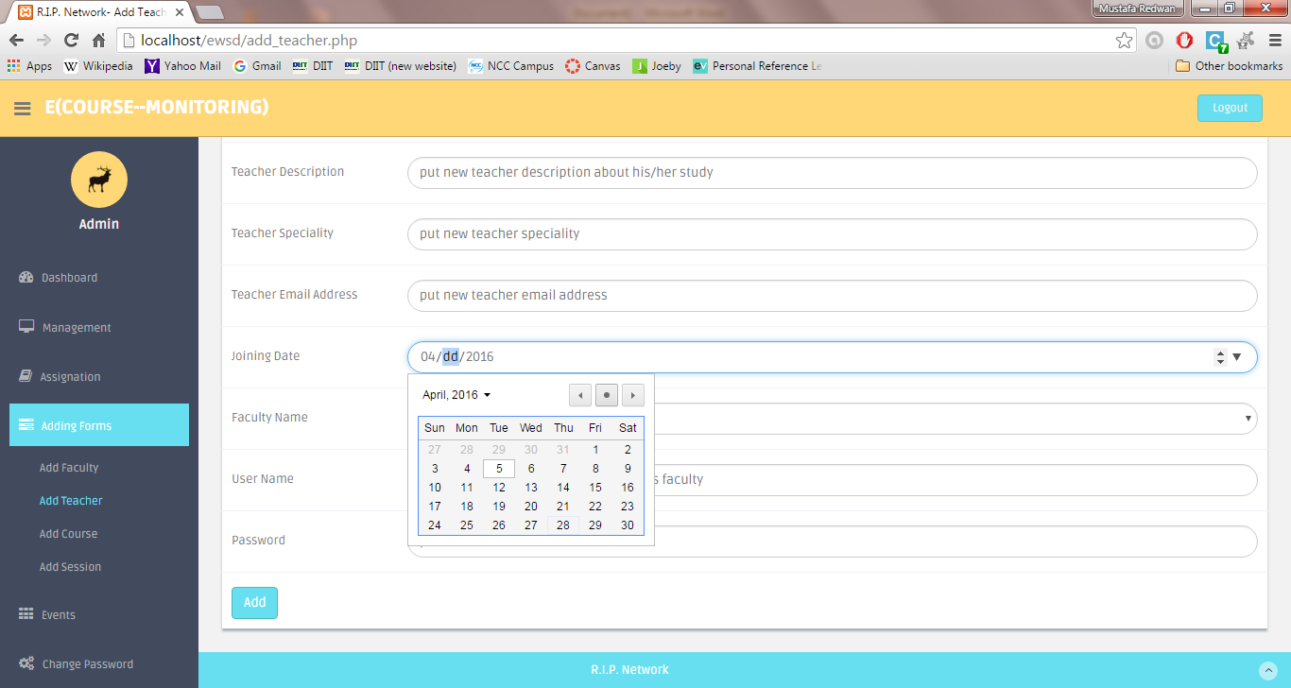

Figure: 7 Today’s date must be chosen as joining date.

* Validation view in course adding page:

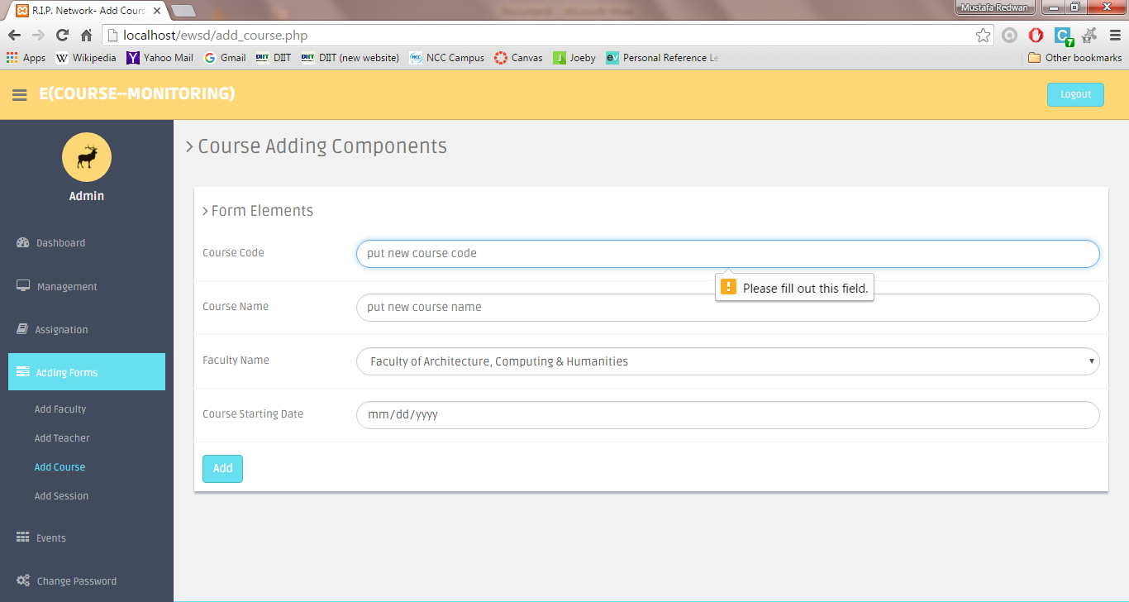

Figure: 8 Course code must be filled up

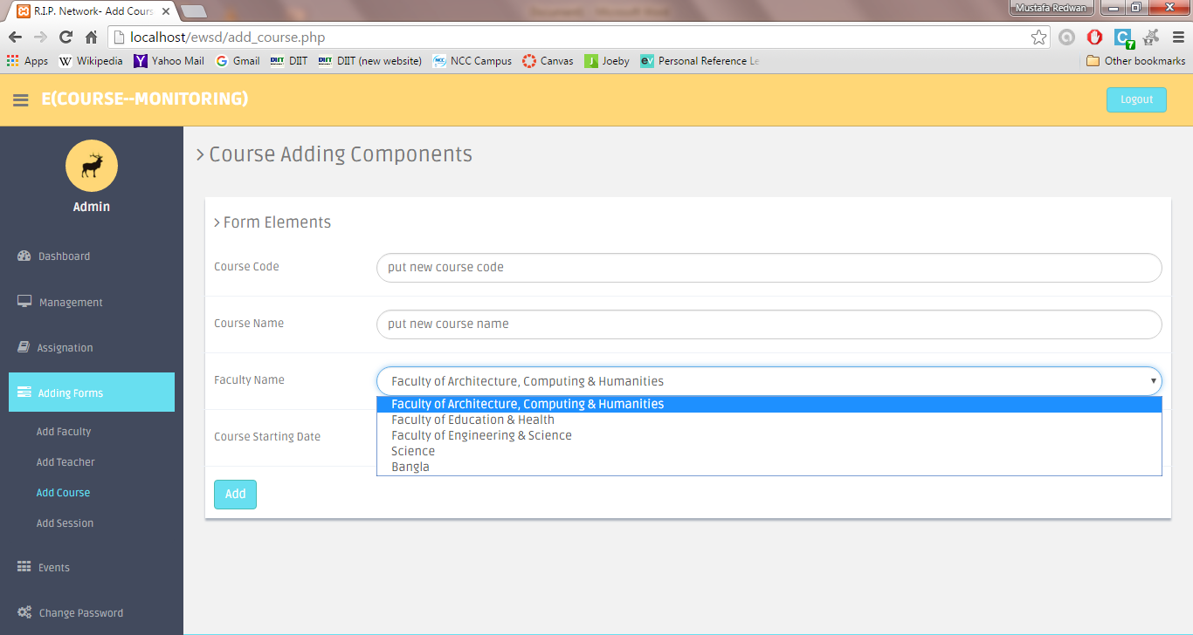

Figure: 9 Faculty name must be selected from drop-down list

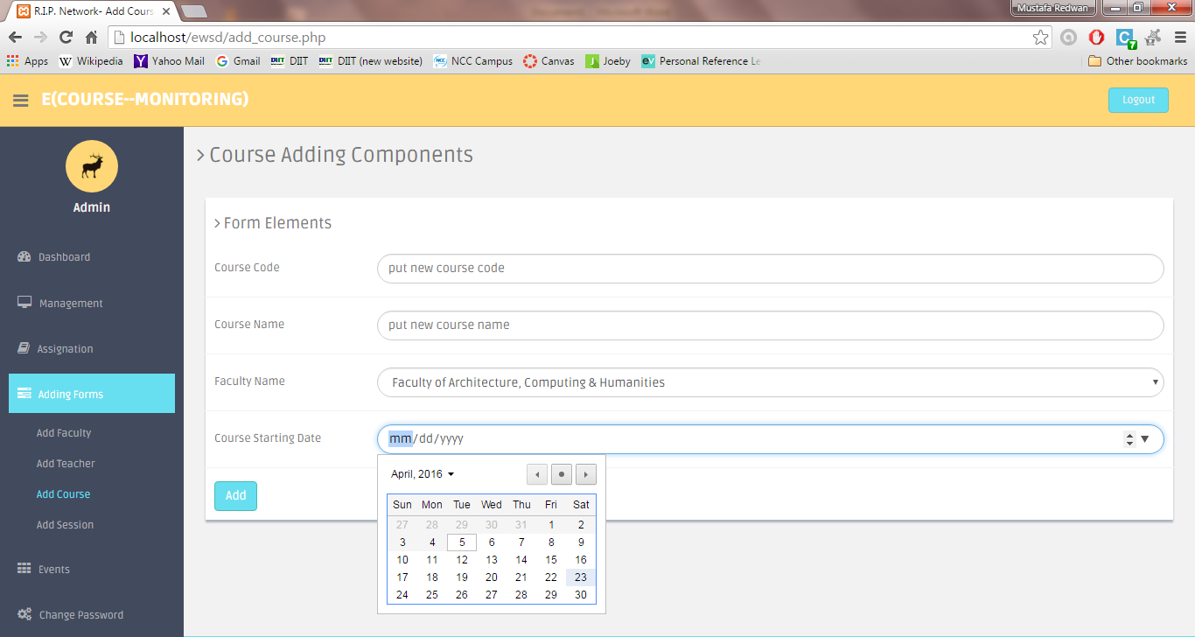

Figure: 10 today’s date or later must be selected. No previous date is allowed.

* Validation view in session adding page:

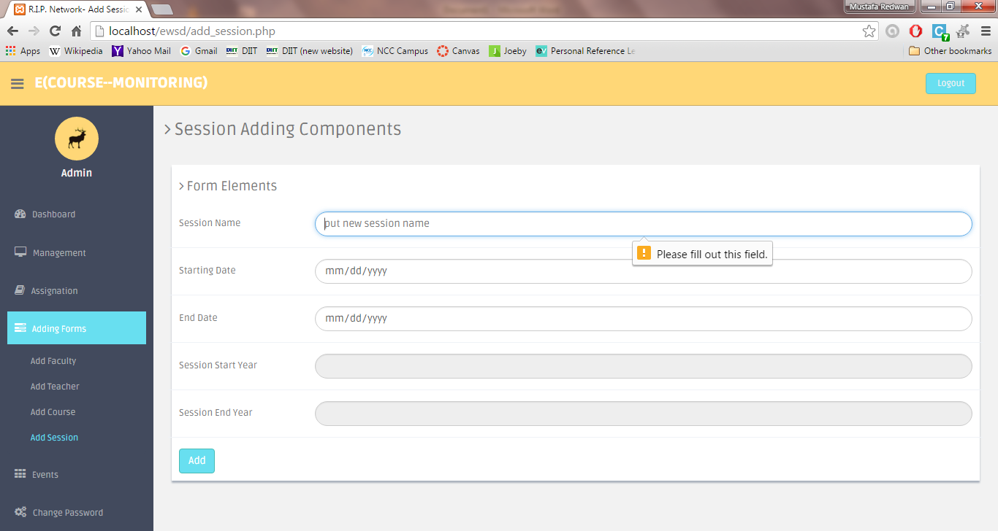

Figure: 11 session name field must be filled up

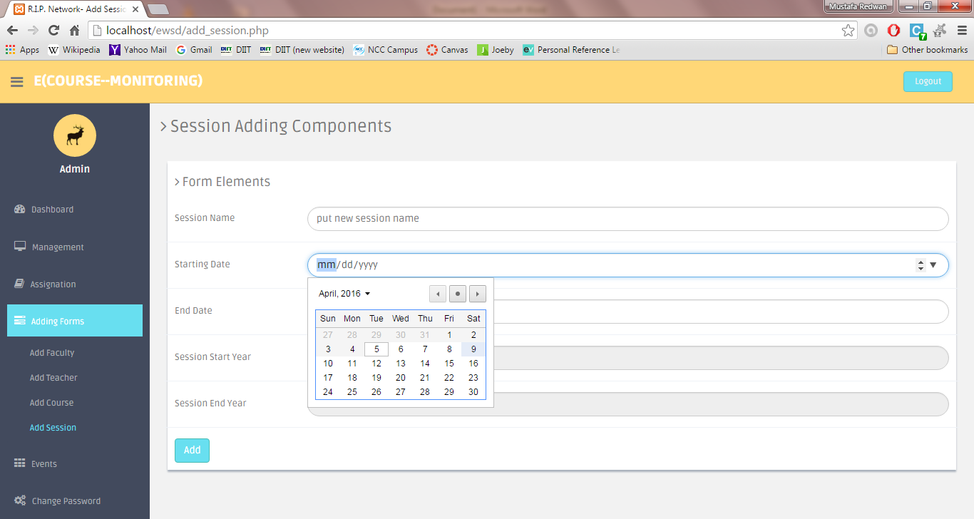

Figure: 12 today’s or later date must be selected for starting date.

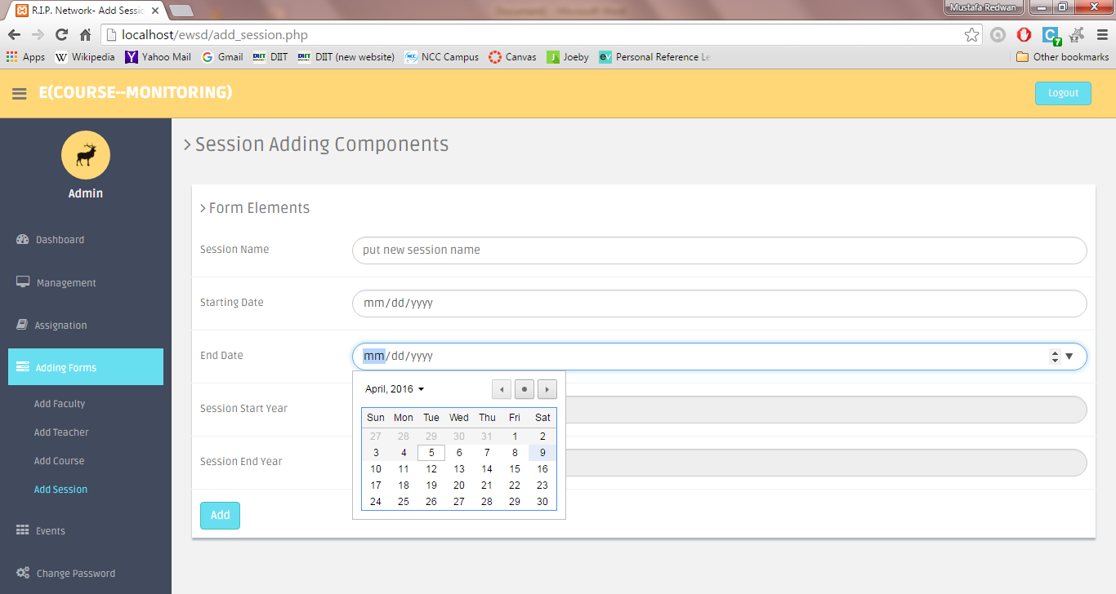

Figure: 13 today’s or later date must be selected. No previous date is allowed.

* Validation view in add event:

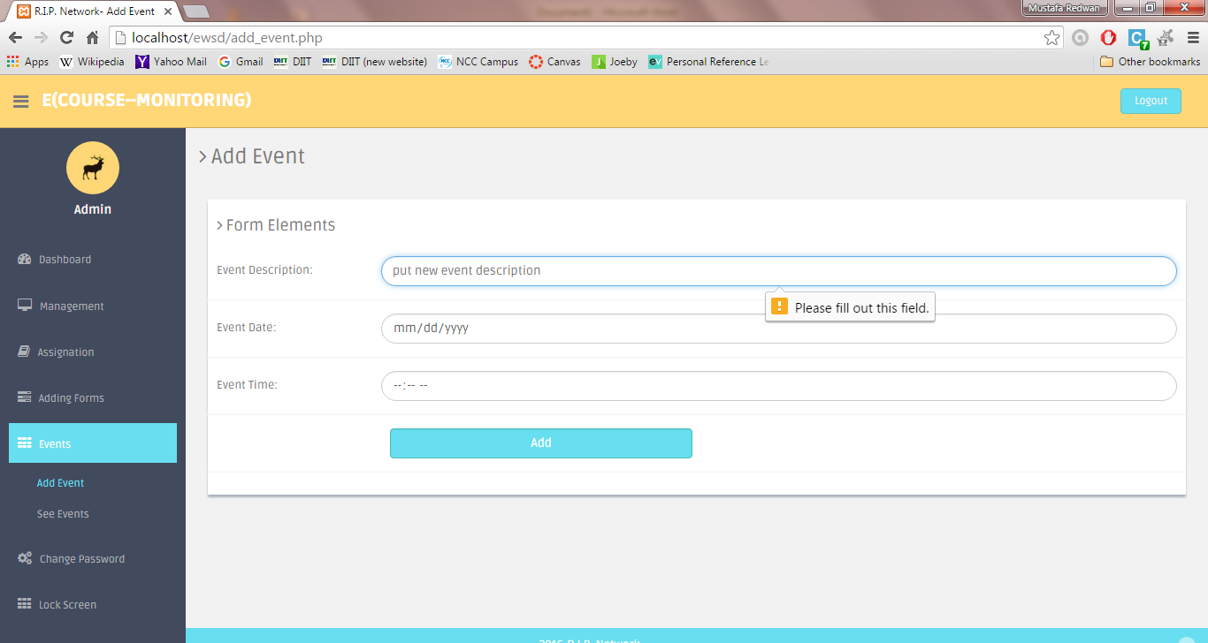

Figure: 14 Event description field must be filled up

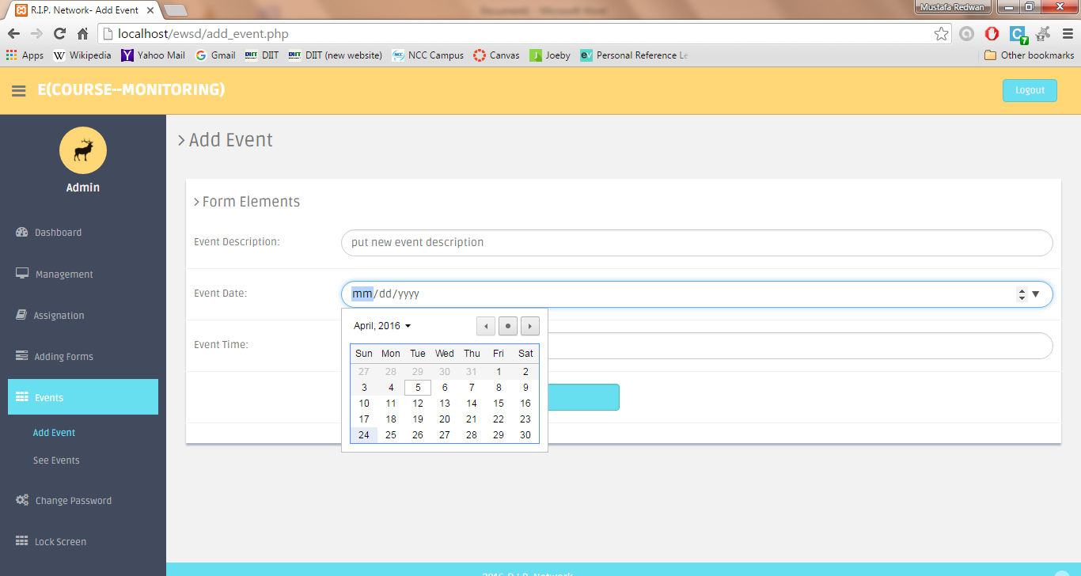

Figure: 15 today or later date must be selected. No previous date is allowed.

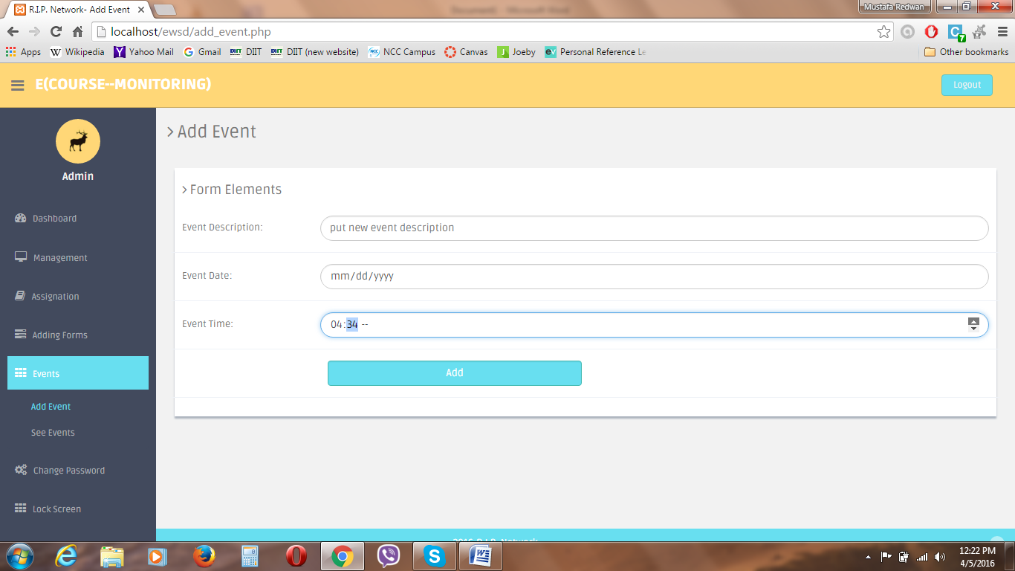

Figure: 16 Time must be entered 10am-5pm as method shown in the screenshot above.

* Validation view in password changing:

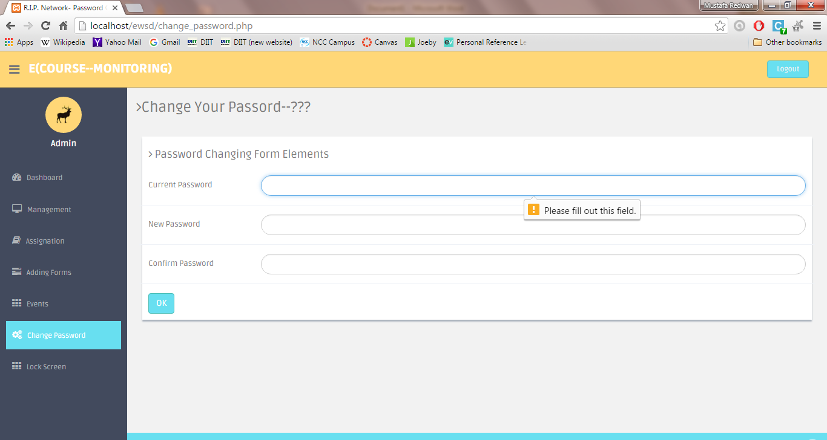

Figure: 17 Current password field must be filled up

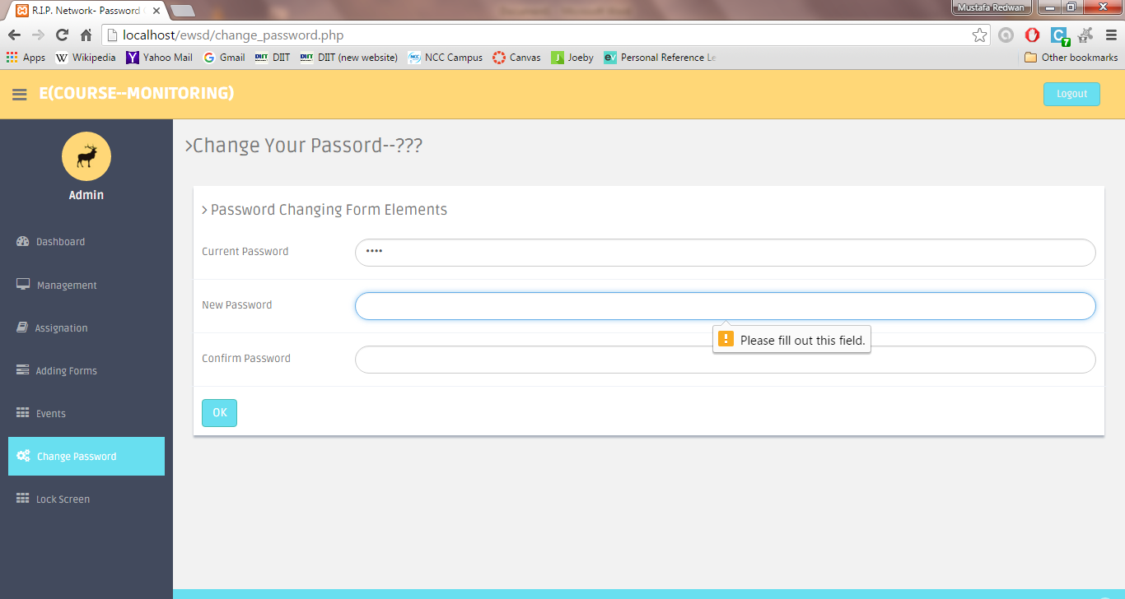

Figure: 18 New & Confirm password must be filled up

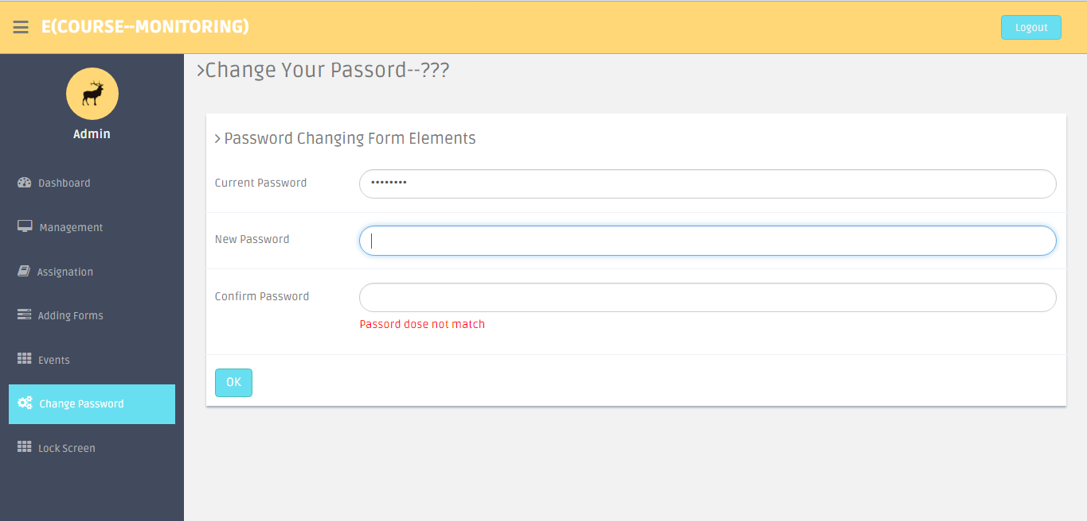  
 Figure: 19 confirm password field must match with new password field.

* Validation view in CMR Create page:

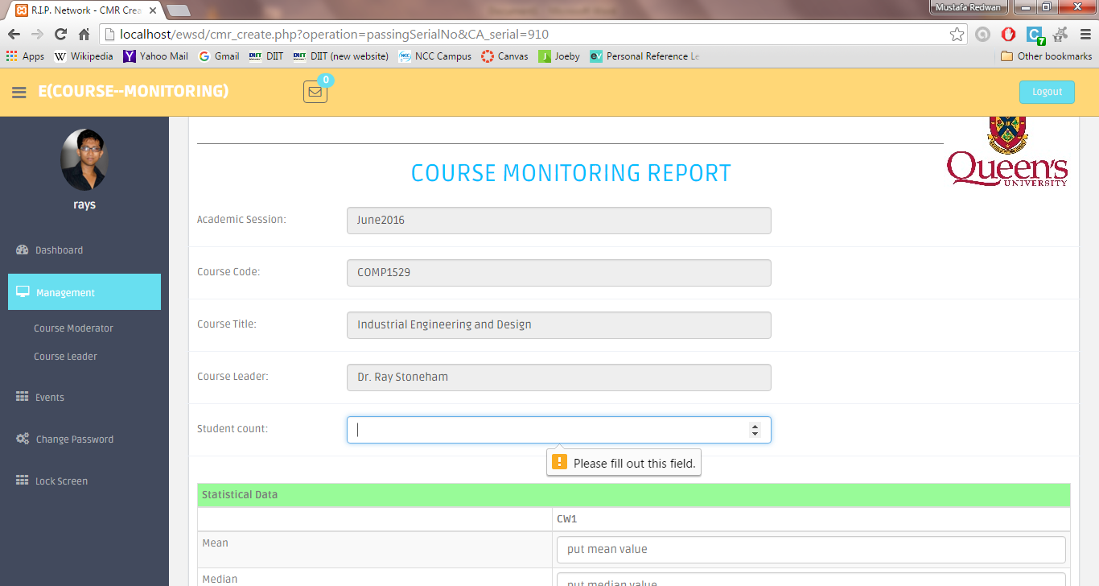

Figure: 20 Student count must be filled up

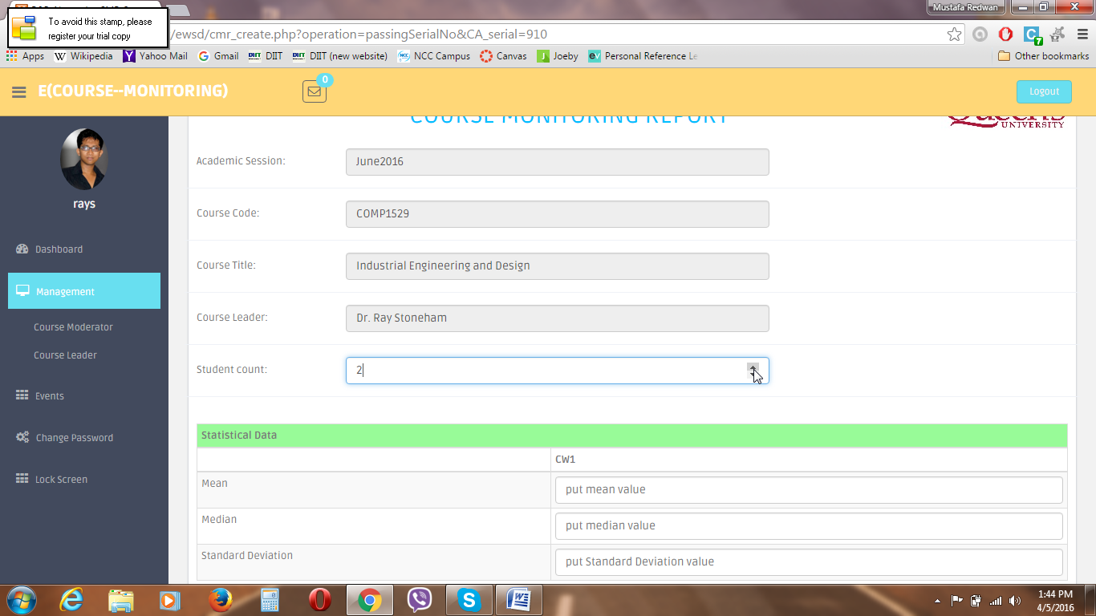

Figure: 21 Entering Student count values by clicking on arrows as shown

* Validation view in faculty authority assignation:

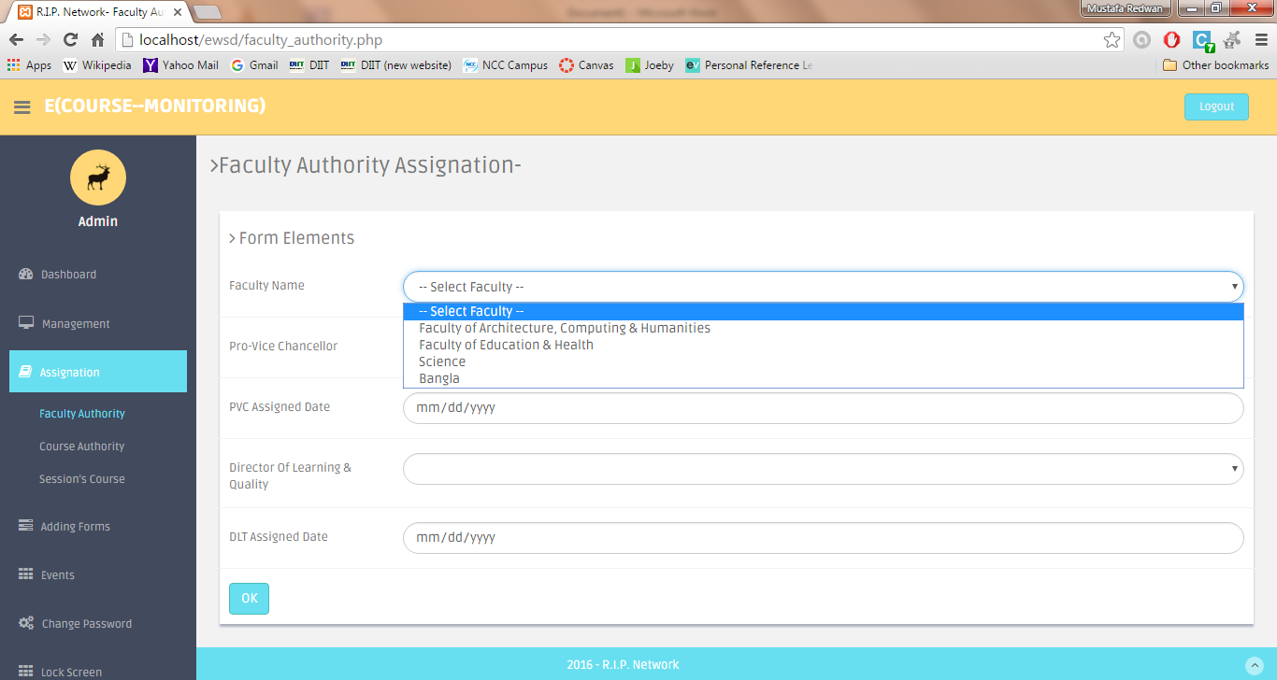

Figure: 22 Faculty name must be selected

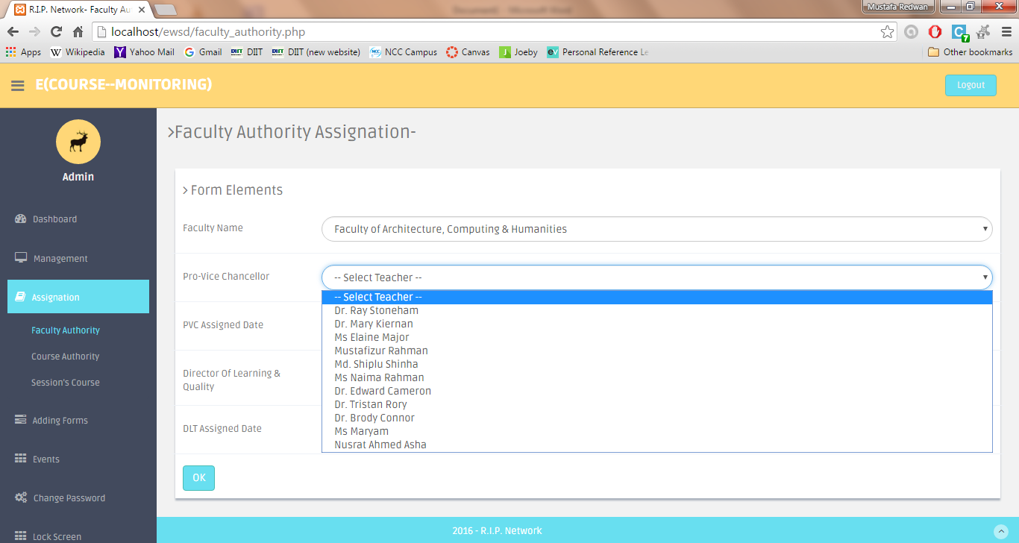

Figure: 23 Pro-Vice Chancellor selection based on selected faculty name

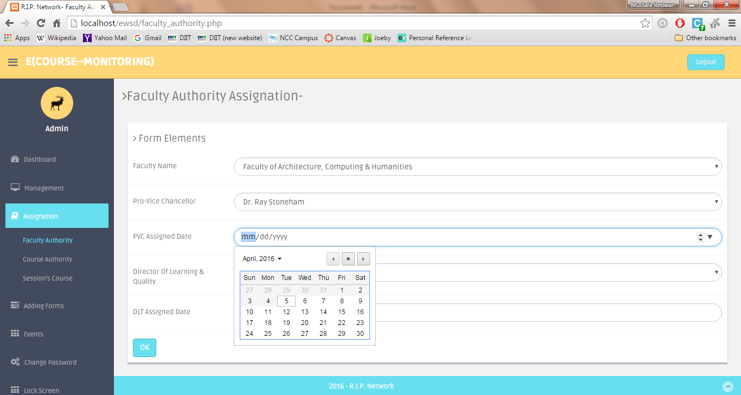

Figure: 24 PVC Assigned date must be today’s date or later date.

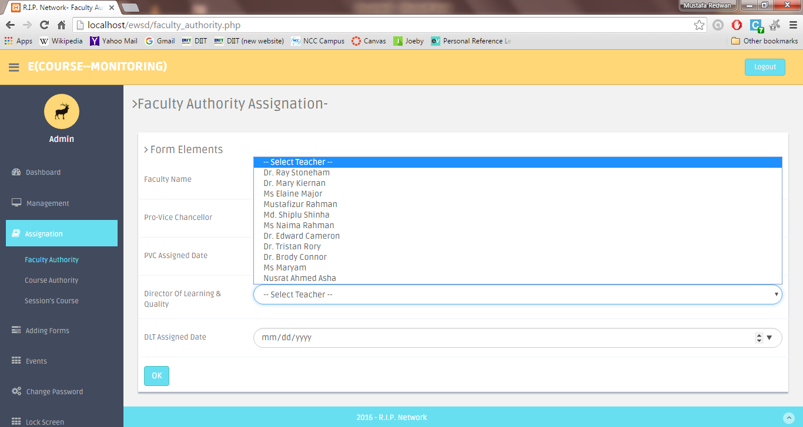

Figure: 25 Director of Learning & Quality selection based on selected faculty name

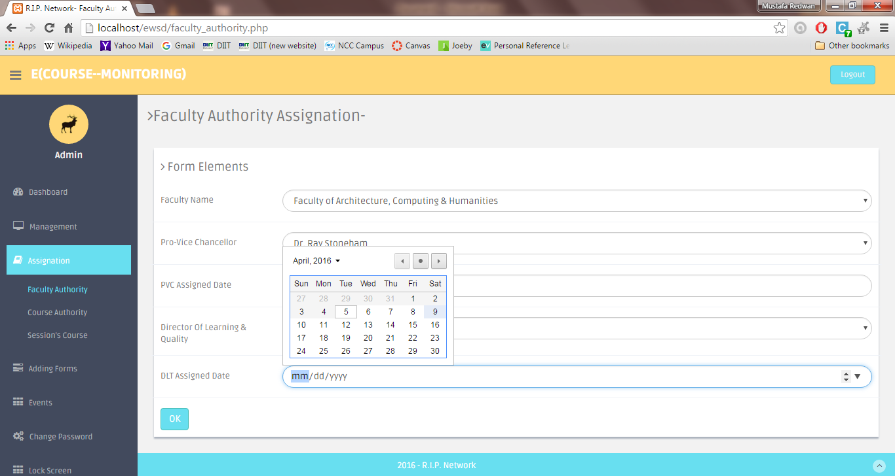

Figure: 26 DLT Assigned Date Must be today’s date or previous date.

* Validation view in course authority:

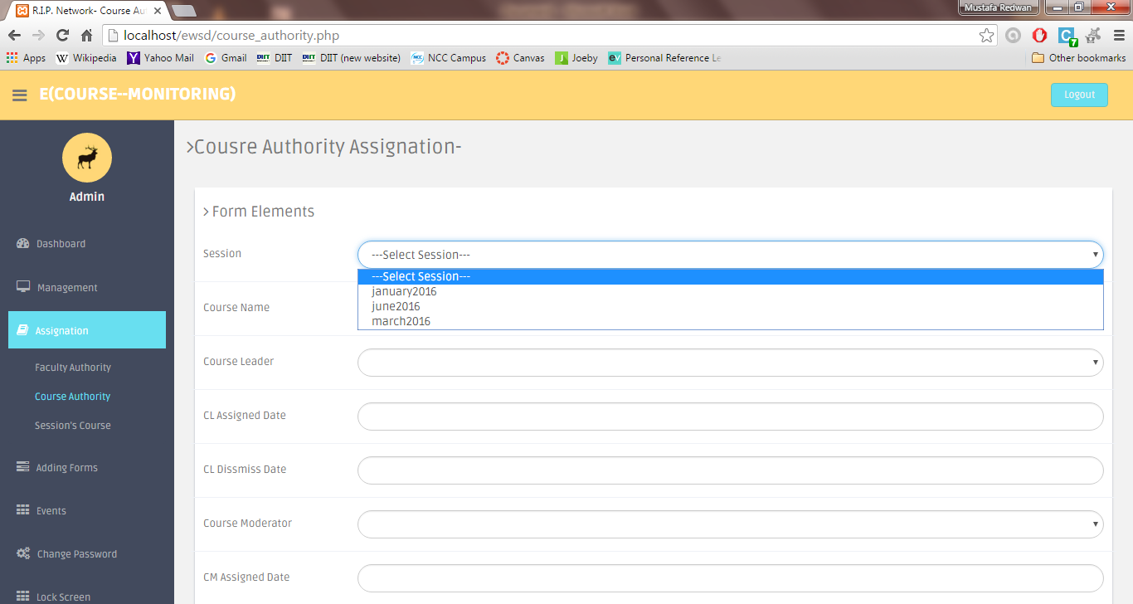

Figure: 27 Session must be selected

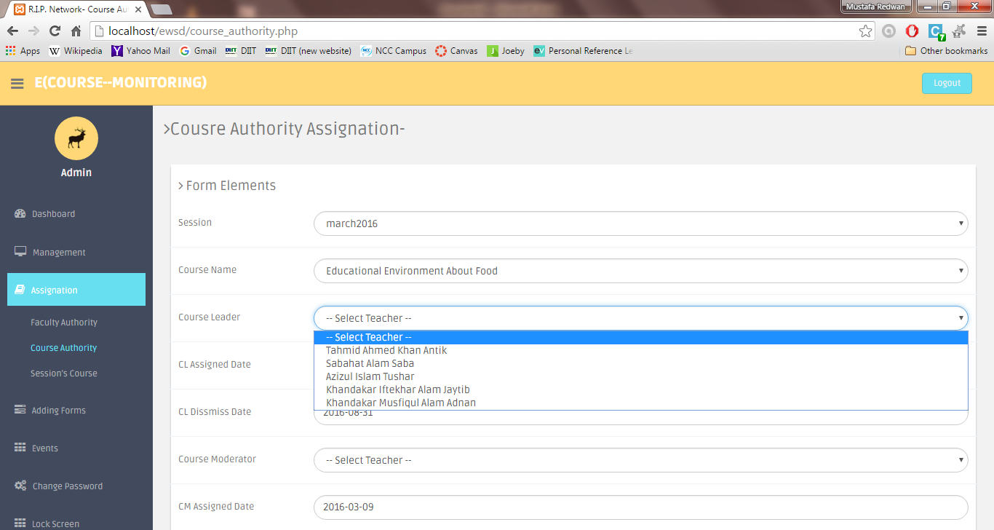

Figure: 28 Course leader Selection based on selected course’s faculty

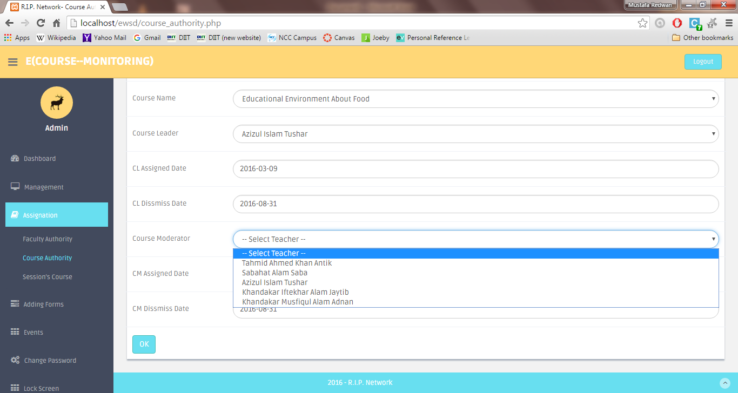

Figure: 29 Course Moderator Selection based on selected course’s faculty

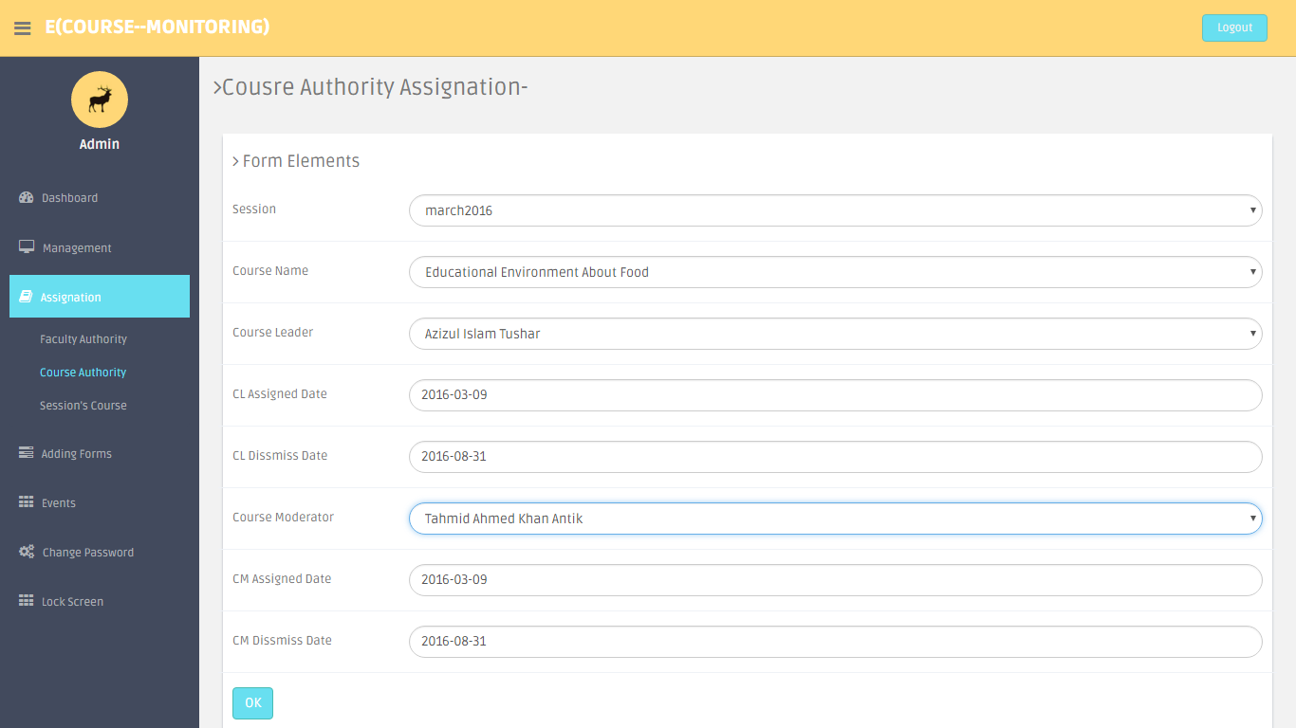

Figure: 30 CL/CM assign/dismiss date auto filled based on selected session

* Validation view in session course assignation:

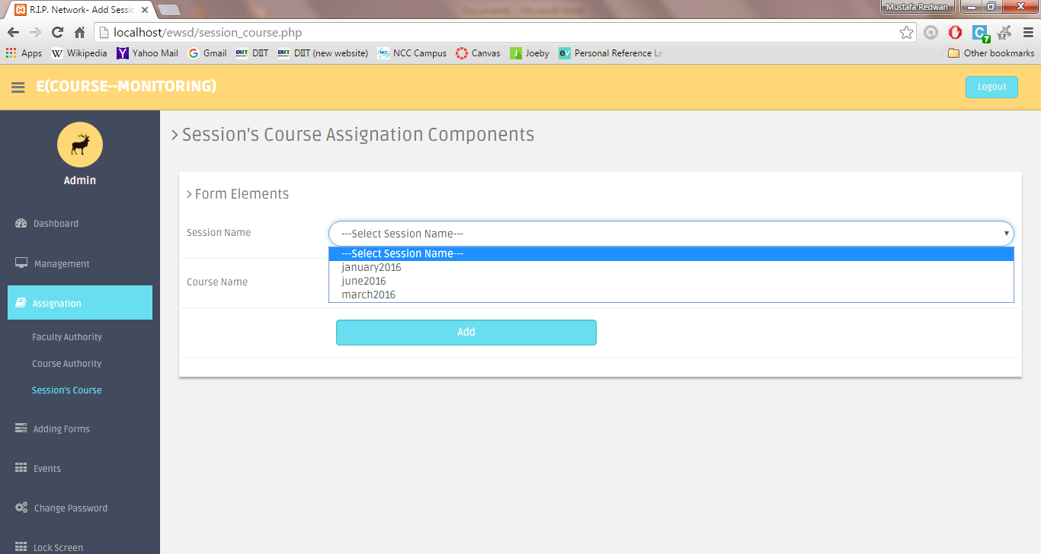

Figure: 31 Session must be selected

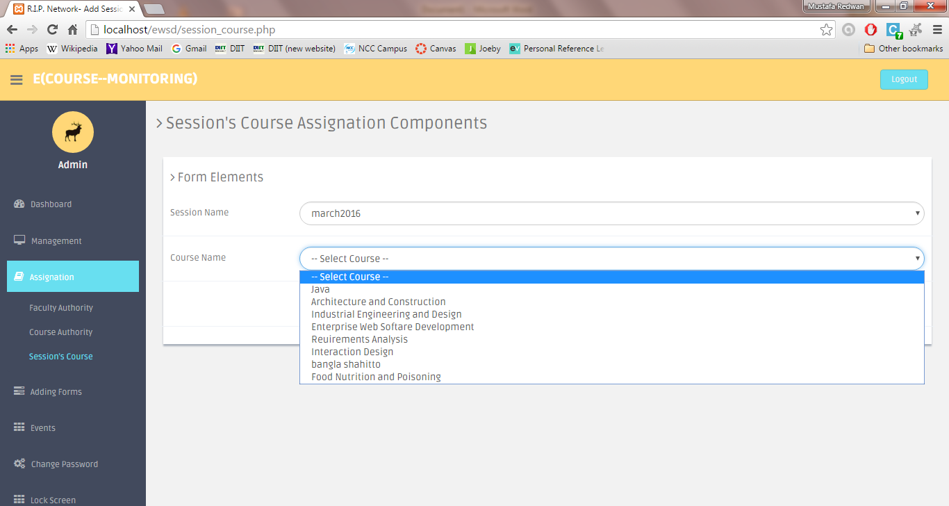

Figure: 32 Course selection based on selected session